Experiment No. 1

AIM : ORACLE Installation Details

Oracle database is a database management system by oracle cooperation. The most fundamental and common usage of oracle database is to share a

predefined type of data. It support the **Structured Query Language** to

manage and manipulate the data that it has one of the most reliable and highly used Relational Database Engine. In this experiment we learn how to install version on Window steps :

Step 1: Go to **Oracle Database Software Downloads** in your browser.

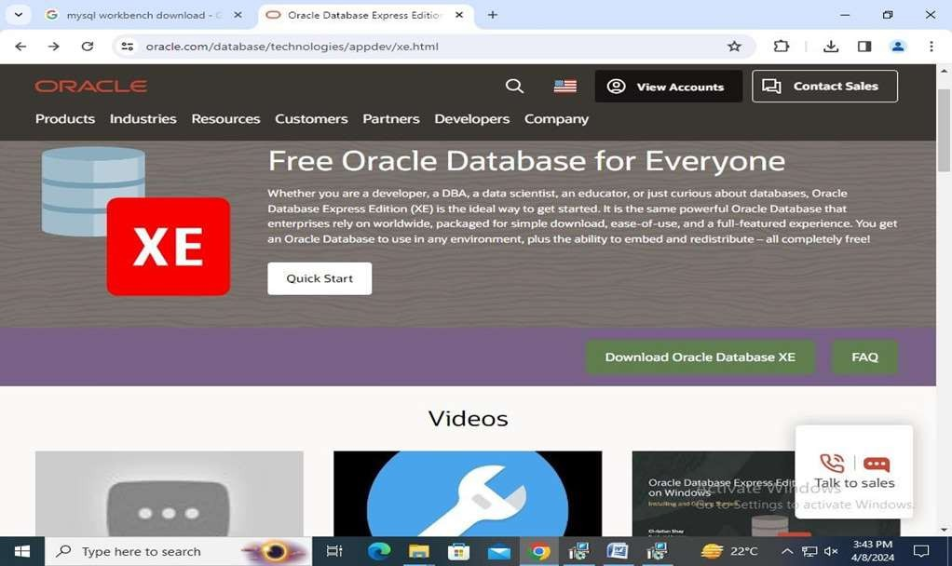

Step 2: Download the 64-bit *.zip* file.

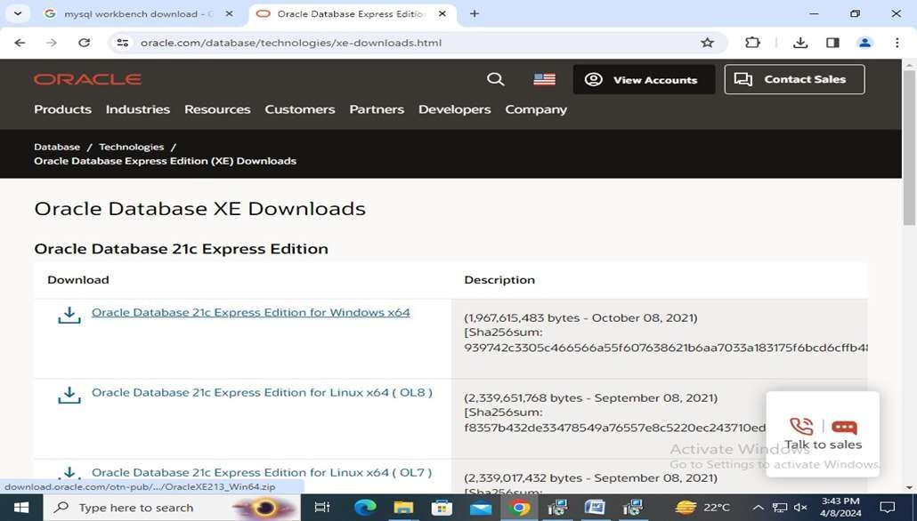

Step 3: Select the *.zip* file and right click to select “Extract All”. Extract both the *.zip* files to the same folder.

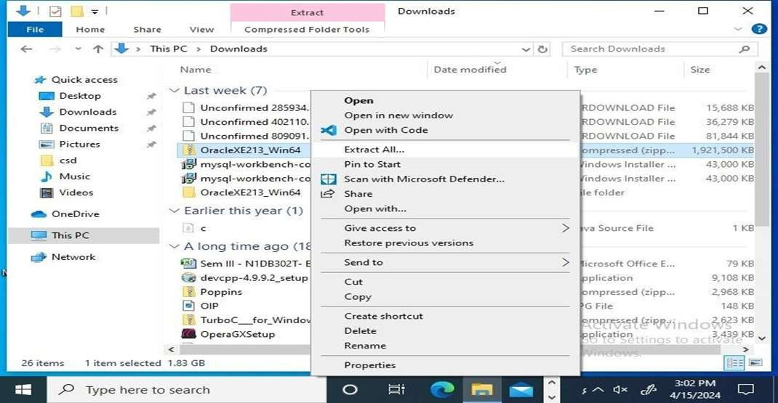

Step 4: Run the *setup.exe* and select the installation options according to your database and Window user requirements.

Click “Install” to install the product. Oracle Database is installed on Windows.

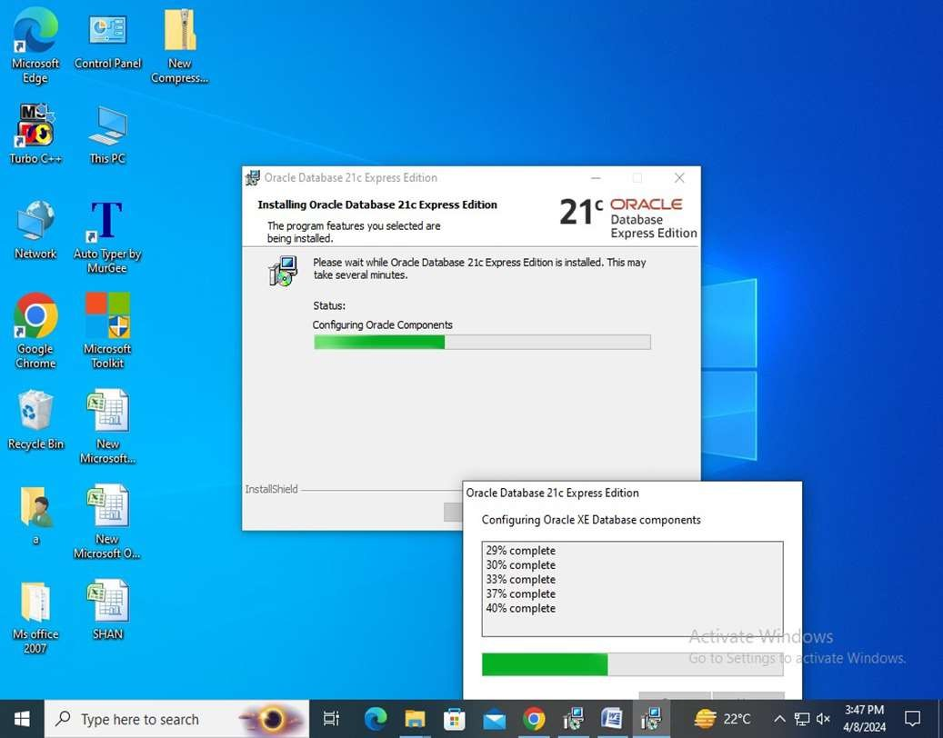

Step 5: Start the SQL Plus Application.

From Windows Start - > click

**Programs**

- > **Oracle-**

**OraDB21Home1** -> **Application Development** -> **SQL Plus**

